C PROGRAMMING
NAME : VISHAAL G
REG NO : 1921260043
COURSE CODE : CSA0222
Task 10: Compare Expectations with Execution
10.1 Compare totals for different numbers of households
For a reproducible comparison, assume every household receives a bill of ₹950.00, corresponding to 350 units consumed.
Number of bills | Total in rupees | Total in paise
4,000 | ₹38,00,000 | 380,000,000
60,000 | ₹5,70,00,000 | 5,700,000,000
800,000 | ₹76,00,00,000 | 76,000,000,000
These totals are illustrative test data, not actual district billing figures.
10.2 Integer overflow analysis
On a typical 32-bit int implementation, the maximum signed integer is 2,147,483,647.
- At 4,000 bills, the total in paise fits in int.
- At 60,000 bills, the total in paise exceeds the signed int range.
- At 800,000 bills, the total in paise also exceeds the signed int range.
- A 64-bit long on common Linux systems can store these totals, but a long may be only 32 bits on other systems.
- long long is the safer choice for a large accumulated total, provided the maximum possible total is within its range.
10.3 Comparison of data types
Type | Main limitation
int | May overflow when storing large totals in paise
long | Size varies by platform
long long | Supports larger integer totals
float | Limited precision for decimal values
double | Greater precision than float, but decimal currency may still be inexact
10.4 Example program
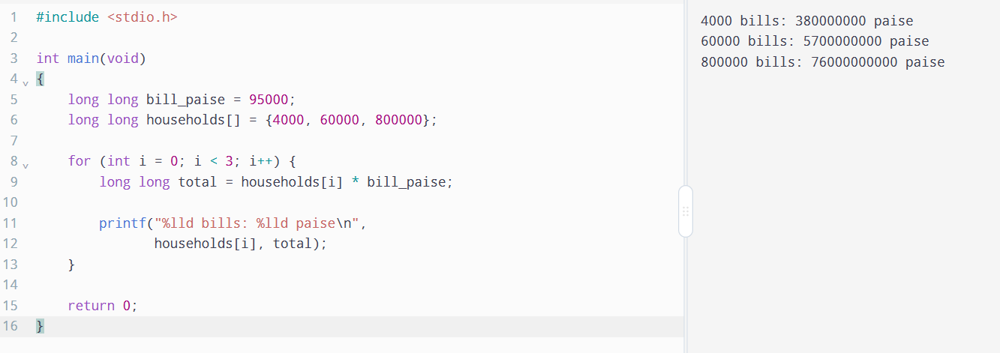
10.5 Alternative: double district total
A double can represent very large totals, but it does not guarantee exact decimal arithmetic. Integer paise provides exact addition until overflow occurs.
Both types use constant time per addition, \(O(1)\). On typical systems, double occupies 8 bytes and long long also occupies 8 bytes. The actual sizes should be confirmed using sizeof.

